# ATS – Asia Ticketing Script

# Application and Set Up Guide

Version No: 12.0

# Prepared by: Nikki Bromwich

# Date: 28 February 2012

Table of Contents

Purpose of the Document 3

Prerequisite 3

Installation 3

*1.1* *Setup Preparation Screen* 3

*1.2* *Welcome Dialog Box* 4

*1.3* *Country Detail Input* 5

*1.4* *Installation Status* 6

*1.5* *Installation Confirmation* 7

Set Up 7

*1.6* *ATS.config File* 8

How to run ATS 10

# Purpose of the Document

This document is the installation and Set Up Guide for ATS – Asia Ticketing Script V12.0. It describes in detail the steps involved to Install and set up the application.

# Prerequisite

* Galileo Desktop Version 1.x or 2.0 or 2.1 or 2.2 this will be updated to include GD 2.5 as will the install shield screen
* Windows® 2000 SP3, Windows® NT Service Pack 6a, Windows® Me and Windows® XP or Higher.
* Microsoft® Internet Explorer 6.0 or Higher

# Installation

Double click on the executable file. 

## *Setup Preparation Screen*

This shows the setup wizard preparation screen to prepare the ATS for setup.

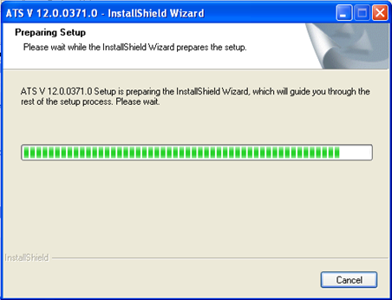

## *Welcome Dialog Box*

For a new install please click “Next”

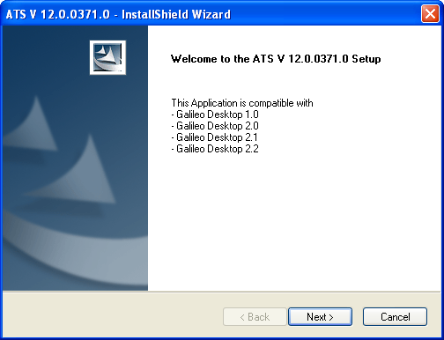

If you are upgrading please select one “Upgrade” and Click Next.

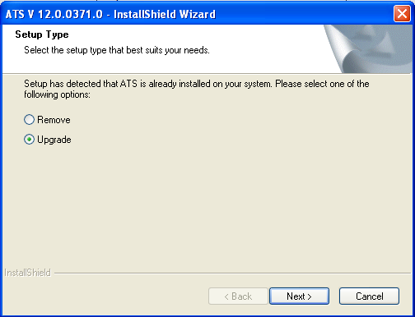

## *Country Detail Input*

The user needs to input their 2 letter country code into this field. Eg. HK, TW, PH, ID etc

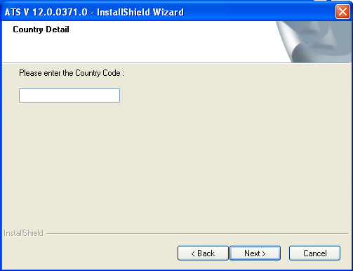

The country code maps back to the table below and the application generates the ‘Country Code’ and corresponding ‘TMU Code’ into the ATS.config file.

ATS uses this value to determine the host entry performed by the script when updating the tour code. Eg. Tour code will be entered as TC-xxx, and Tour Code (AI) will be entered as AI-xxx.

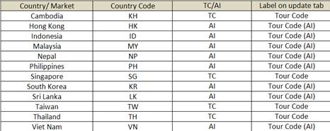

Please note changes to the above table need to be completed by development therefore please raise an incident if this table is incorrect. A quick work around (until the table is updated) is to change the country code. Eg. I’m located in HK however I need the tour code entered as TC-xxx therefore I would update the country code and TMU field to SG, TC respectively.

To assist agents it also shows visually on the update screen to allow the user to see the entry that will be used.

 or 

If this box is left blank, or an invalid country code is entered the following error is displayed and the install shield will close.

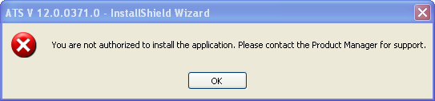

## *Installation Status*

Shows the status of the installation

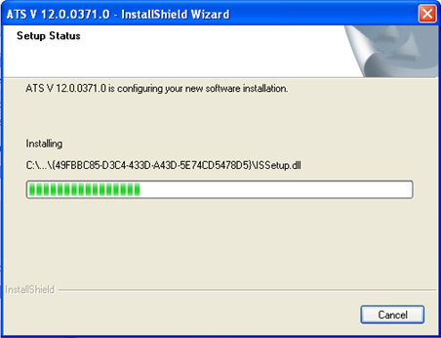

## *Installation Confirmation*

Confirm the script has been successfully upgraded. Click “Finish” to exit the wizard.

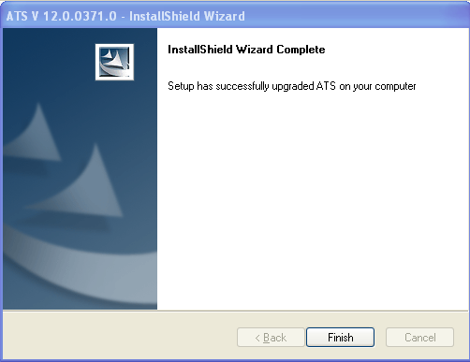

# Set Up

ATS will be installed in the CustomViewpoint Folder on the C drive. It is made up of the following files/folders, which run the application therefore please do not delete or move any of these files. The debug log is used for support purposes and will be discussed in the support guide.

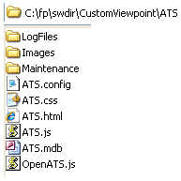 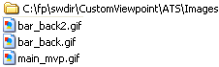 

## *ATS.config File*

The config file houses the data used by ATS and is opened in a notepad file. Only the following 3 fields can be changed if required, all other fields can not be amended as it would stop the application from working.

1. **FreqPTCDay** allows the agent to control how often the Passenger Type Codes are downloaded. If it’s set to 1, once a day ATS will request the PTC list from host and update this, therefore the first time ATS runs it will be slightly slower as it’s reading and applying these values to the Names screen. This field allows for a numeric value between 1-10.

cid:image001.png@01CCF702.7545B680

</configSections>

   <FreqPTCDay>

               <FreqPTCDayValue>1</FreqPTCDayValue>

   </FreqPTCDay>

1. **CommandDescValue** allows the agent to control if the command box is displayed within ATS or not. If activated the command box shows at the bottom of the application and shows the host entries being performed by the script. This field allows for the values TRUE or FALSE.

<CommandDesc>

               <CommandDescValue>FALSE</CommandDescValue>

   </CommandDesc>

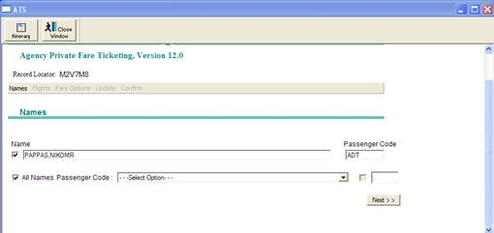

<CommandDesc>

               <CommandDescValue>TRUE</CommandDescValue>

   </CommandDesc>

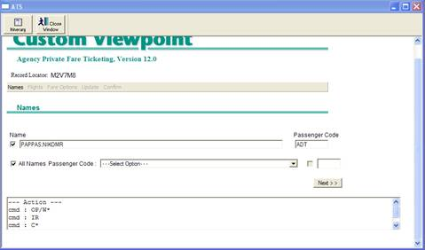

1. **SpecificCountryDetails** allows the agent to manually add their Country and TMU code. This is automatically added during installation however if agents want to change this field they can. This field allows the values found in the table below only.



<SpecificCountryDetails>

                        <CountryCode>SG</CountryCode>

                        <TMUCode>TC</TMUCode>

            </SpecificCountryDetails>

Please note if this is manually updated the Country and TMU codes must match the table (shown above) or the following error will be returned when you run the application.

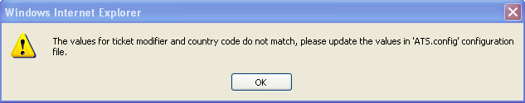

# How to run ATS

Once the installation is complete an icon will appear on Gal Desktop.

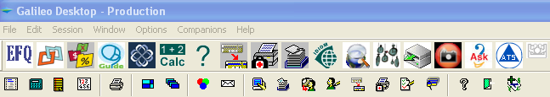

For details of how to use the application please refer to the user guide.